*Singing Our Faith # 428 “For the Healing of the Nations”
*Blessing and Dismissal
*Postlude
Scatter to Serve God & Neighbor
Welcome to all! We gather to praise God for the innumerable blessings given
to us and to grow deeper in the Spirit. Joyfully, let us lift our hearts to God.
**Calendar**
Monday, 5/16 |  | Articles due for June newsletter.
 | 6:30 p.m. | Wesleyan Group @ Charley’s Restaurant
Thursday, 5/19 | 6:30 p.m. | Choir resumes
Hospital: VCU Medical Center (Richmond): Carolyn Stewart
Lynchburg General: Robbie Perrow
Graduates
Be sure and contact the church office by phone (239-8423) or email us (chestnuthillumc@comcast.net) if you, or a family member, will be graduating from high school or college this year!
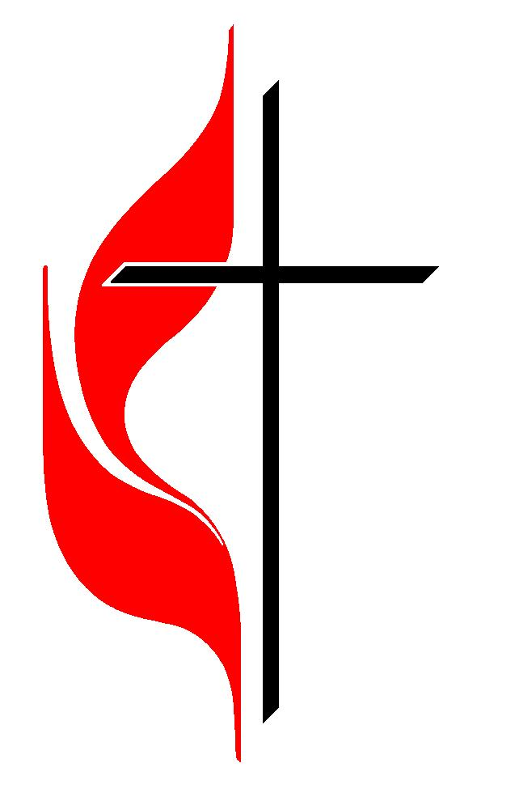
In the Grocery Cart This Month
For May ~ Cereal.
Place donations in the grocery cart, located in the Commons.

DIRECTORY OF CHESTNUT HILL UNITED METHODIST CHURCH
Sharma Lewis | Richmond Area Resident Bishop
Denise Bates | Lynchburg District Superintendent
Adam White | Minister
Steve Stadtherr | Associate Minister
Monica Campbell | Administrative Assistant
Heather Wilson | Director of Music Ministry
Judy Martin | Bookkeeper
Judy Robertson | Lay Leader


Chestnut Hill
United Methodist Church

Making disciples of Jesus Christ
for the transformation of the world.
You are welcome at Chestnut Hill UMC.

4660 Fort Avenue ~ Lynchburg, Virginia 24502
Church: 434-239-8423
Minister’s Cell: 434-944-7723, Minister’s Email: awhite@ves.org
Associate Minister’s Cell: 434-841-2458
Associate Minister’s Email: sps83.ss@gmail.com
chestnuthillumc@comcast.net ~ on the web at chestnuthillumc.net
Find us on Facebook: Chestnut Hill United Methodist Church

Chestnut Hill United Methodist Church
10:30 a.m. ~ May 15, 2022 ~ Fifth Sunday of Easter

Our ministry vision for the Virginia Annual Conference is “to be disciples of Jesus Christ who are lifelong learners, who influence others to serve.”
Welcome! Join us in worshiping God!
Prelude
Welcome and Ministry Announcements
Welcome in the name of Christ our Lord.
Thank you for silencing cell phones as we gather to worship God.
Invocation
Greeting
Like the murmur of the dove’s song,
like the challenge of her flight,
like the vigor of the wind’s rush,
like the new flame’s eager might:
come, Holy Spirit, come.
To the members of Christ’s body,
to the branches of the Vine,
to the church in faith assembled,
to her midst as gift and sign:
come, Holy Spirit, come.
With the healing of division,
with the ceaseless voice of prayer,
with the power to love and witness,
with the peace beyond compare:
come, Holy Spirit, come. (Carl P. Daw, 1981)
*Singing Our Faith # 62 “All Creatures of Our God and King”

Opening Prayer
Almighty God, whom truly to know is everlasting life: Grant us so perfectly to know your Son Jesus Christ to be the way, the truth, and the life, that we may steadfastly follow his steps in the way that leads to eternal life; through Jesus Christ your Son our Lord, who lives and reigns with you, in the unity of the Holy Spirit, one God, forever and ever. Amen.
Greeting Friends and Neighbors
Prayer for Illumination
O Lord, your Word is a lamp to our feet and a light to our path. Give us grace to receive your truth in faith and love, and strength to follow on the path you set before us; through Jesus Christ our Lord. Amen.
Scripture Lesson John 13:31-35 & 15:1-8
The Word of God for the people of God.
Thanks be to God.
Singing Our Faith # 408 “The Gift of Love”
The Good News “How Does Your Garden Grow?”
Special Music “As the Deer”
Bringing Forward God’s Tithes and Our Gifts
*Doxology # 95 Praise God from whom all blessings flow; praise him, all
Creatures here below; praise him above, ye heavenly host; praise Father, Son, and Holy Ghost. Amen.
Prayer of Thanksgiving
Sharing of Joys and Concerns
The Lord’s Prayer
Our Father, who art in heaven, hallowed be thy name. Thy kingdom come,
Thy will be done on earth as it is in heaven. Give us this day our daily bread and forgive us our trespasses, as we forgive those who trespass against us. And lead us not into temptation, but deliver us from evil. For thine is the kingdom, and the power, and the glory, forever. Amen.

